**What is Google Cloud Platform (GCP)?**

* *Google Cloud Platform (GCP) is a suite of cloud computing services provided by Google*.
* It offers a wide range of services, including computing power, storage, databases, machine learning, networking, and more, all delivered over the internet.
* GCP enables businesses to build, deploy, and scale applications and services quickly and efficiently without the need to invest in or manage physical infrastructure.

**What is Google App Engine (GAE)?**

* Google App Engine (GAE) is a fully managed Platform-as-a-Service (PaaS) offered by Google Cloud Platform for running scalable web and mobile applications.
* It dynamically scales applications based on demand, leveraging Google’s robust infrastructure.
* GAE provides a secure environment and various built-in services like scalable data stores, task queues, in-memory caching, and cron tasks, simplifying the development of high-performance apps.
* The App Engine SDK allows developers to design, test, and emulate applications locally before deploying them to the cloud.
* Supported languages include Python, Java, and Go. Developers can control costs through quotas and make their applications accessible to users.

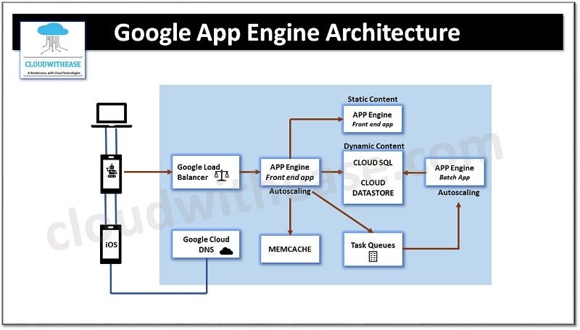

**Key Components of GAE**

**1. Environments**

* **Standard Environment:** Predefined runtime environments for languages like Python, Java, Node.js, Go, and PHP. Applications run in sandboxed environments with automatic scaling and enhanced security, making it ideal for lightweight and low-latency apps.
* **Flexible Environment**:
  + Allows custom runtimes via Docker containers. Suitable for applications requiring libraries not supported by Standard.
  + Scales manually or automatically with more control over resources.

**2. App Instances :**

Applications run on lightweight **virtual machines (VMs)** called instances. These are dynamically created or deleted based on traffic and application demand.

**3. Datastore and Storage**

* **Cloud Firestore:** A serverless NoSQL database for storing structured data.
* **Cloud SQL:** Managed relational databases like MySQL and PostgreSQL.
* **Cloud Storage:** Suitable for large files, media assets, and binary data.

**4. Memcache**

To improve performance, GAE includes a distributed in-memory caching system called **Memcache**, which reduces database load and enhances response times by caching frequently accessed data.

**5. Task Queues**

Used to manage background tasks or asynchronous processing (e.g., processing logs, sending emails).

**6. Services and Modules**

GAE supports **modular architectures**, where applications are divided into smaller, independent services (microservices). Each service can have its own runtime, scaling configuration, and resource allocation, allowing for efficient scaling and maintenance.

**7. Monitoring and Logging**

* **Cloud Monitoring**: Tracks performance, latency, and error rates.
* **Cloud Logging**: Logs application errors, requests, and debugging information.

**How Google App Engine Works**

1. **Development:** Developers write application code using a supported language or framework. The code is then prepared for deployment using predefined runtimes or custom configurations.
2. **Deployment:** Applications are deployed to GAE using the Google Cloud CLI, Cloud Console, or IDE plugins. Developers can push multiple versions of the app simultaneously.
3. **Routing and Scaling:** Incoming requests are routed to app instances by Google’s global load balancers. GAE automatically scales instances up or down based on demand.
4. **Data Management:** Persistent data is stored in Firestore, SQL databases, or other Google Cloud services, depending on the application's requirements.
5. **Error Reporting and Monitoring:** Errors are captured in real time using Cloud Logging and Stackdriver Error Reporting, while Cloud Monitoring tracks application performance metrics.

**Services Provided by Google App Engine**

1. **Hosting for Web Applications and APIs** : Deploy and scale dynamic web applications or backend services.
2. **Language Support** : Built-in support for languages like Python, Java, Node.js, Go, Ruby, PHP, and more through standard or flexible environments.
3. **Auto-Scaling** : Dynamically adjusts the number of instances to match the incoming traffic.
4. **Integrated Database Services**
   * Use **Cloud Firestore** for NoSQL needs.
   * Use **Cloud SQL** for relational databases.
5. **Version Management** : Deploy multiple versions of an application and test them in real-time.

**Advantages of Google App Engine**

1. **Ease of Use** : Simplifies app development and deployment with serverless infrastructure.
2. **Automatic Scaling** : Apps scale automatically to handle millions of requests with no manual intervention.
3. **Multi-language Support** : Native support for multiple languages and the ability to use custom runtimes.
4. **Built-in Security** : Automatic HTTPS, firewall configurations, and role-based access control.
5. **Cost Management** : Pay only for what you use (compute time, storage, etc.).

**Disadvantages of Google App Engine**

1. **Vendor Lock-in** : Applications tightly coupled with GAE APIs may face challenges during migration to other platforms.
2. **Cold Starts** : Applications might experience delays when spinning up instances after inactivity.
3. **Limited Customization** : Developers have less control over the infrastructure compared to IaaS platforms.
4. **Complex Pricing** : Pricing can become unpredictable for high-traffic applications with many resources.
5. **Sandbox Limitations** : Standard environments have restrictions on libraries and filesystem access.